---------------------------------------------------------------------------------------------------------------------------------

Shock module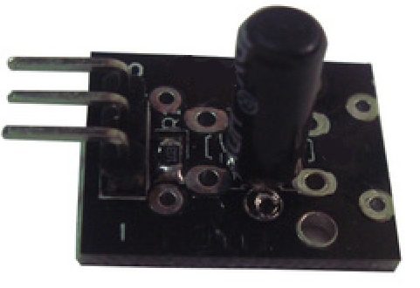

Shock module can connect UNO R3 PIN13, make shock test.
Pin 13’s LED，use shock module connect Pin 3. When shock module test there is some shock, led can be bright.

Code:

int Led=13;//定义LED 接口
int Shock=3//定义震动传感器接口
int val;//定义数字变量val
void setup()
{
pinMode(Led,OUTPUT);//定义LED 为输出接口
pinMode(Shock,INPUT);//定义震动传感器为输出接口
}
void loop()
{
val=digitalRead(Shock);//将数字接口3的值读取赋给val
if(val==HIGH)//当震动传感器检测有信号时，LED 闪烁
{
digitalWrite(Led,LOW);
}
else
{
digitalWrite(Led,HIGH);
}
}

